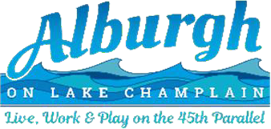

**ALBURGH SELECTBOARD SPECIAL MEETING MINUTES**

**Meeting time & date:** June 21st, 2025, at 6:00PM

**Meeting location:** Alburgh Town Office (Conference Room) - 1 N Main Street

**Public Officials Present:** Elliot Knight, Jim Hokenberg, Alex McCracken, Damien Henry, Russell Duchaine

1. Call to Order – Elliot Knight called the meeting to order at 6:15PM after technical difficulties from the power cord having been removed from the conference room computer.
2. Adjustments to the agenda- none
3. Minutes from Prior Meetings- approval of 6/23 minutes was tabled
4. Public Comments- Steve Mikel Spoke about plans for a playground at Terry Tatro Bicentennial park and that equipment is now on sale.

Damien Henry updated the board on the cemetery revitalization efforts and mentioned that many stones had been patched, polished and repaired.

1. Executive Session- Damien Henry motioned to enter into executive session to discuss town administrator candidates, Alex McCracken seconded, the board voted unanimously in favor.

The board exited Executive Session, and there were no motions or further discussion in open session.

1. Finances- The board Signed Warrants
2. Adjourn- Alex McCracken motioned to adjourn, Damien Henry Seconded, the board voted unanimously in favor and the meeting was adjourned.