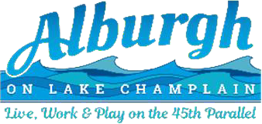

NOTICE and AGENDA

# Alburgh Special Selectboard Meeting

# 6/16/2025

The Selectboard will meet in the municipal office conference room located at 1 N Main Street on Monday, June 16th at 6:00PM. To join remotely: enter this link: <https://us06web.zoom.us/j/5043834193>, Meeting ID Code: 504-383-4193

# MEETING AGENDA

1. 6:00PM – Call to Order
2. 6:01PM – Alburgh Family Clubhouse (AFC) – warrant for grant passthrough funds
3. 6:05PM – Town administrator - position description and candidate search
4. 7:00PM – Adjourn