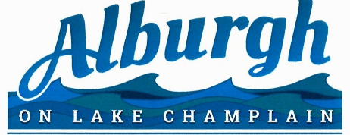
April 9, 2024

Invitation to Bid: Cleaning of Town Office

The Town of Alburgh is seeking bids to clean the Alburgh Town Office, located at 1 North Main Street, to begin July 1st, 2023.

Scope of work:

Vacuuming, Dusting, Bathrooms, Mopping floors, Front Windows, all windows twice per year, Trash bins

Deadline:

Bids must be sent to the Town Administrator at: agoddard@alburghvt.org and received by Monday, June 1^{st,} 2024 at 5PM. Please include weekly and bi-weekly quotes. **Please note**: Proof of insurance must accompany the bid.

If you have any questions regarding this bid, please contact the Town Administrator at 802-330-7642

