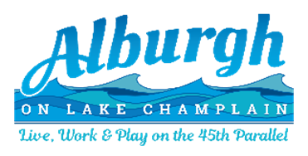

NOTICE and AGENDA
Alburgh Selectboard Regular Meeting
– 2/12/2024 –

The selectboard will meet in the municipal office conference room on Monday, February 12th at 6 PM. To join remotely, please got to: https://us02web.zoom.us/j/5043834193
- 6:00 PM – Call to Order
- 6:00 PM – Adjustments to the Agenda
- 6:05 PM – Minutes from prior meeting
- 6:10 PM – Highway Department
  - Sidewalk plow incident – VT Bakehouse

- 6:30 PM – Transfer Station
  - NWSWD transition – debrief of most recent discussions on the potential transition.
- 6:40 PM – Town Office
  - Town clerk found vintage banners that could be hung on the electrical poles on Route 2.
    - Quote on brackets if the board wants to hang them up.

  - Administrative contracts
    - NEMRC Cloud Service Agreement
    - LHMP Grant Contract
    - GICSD FY25 Contract

- 7:00 PM – New/Old Business
  - Total Solar Eclipse
    - Community leadership meeting, Tuesday, Feb 12th at 6PM
    - Alburgh Community Festivals, Inc request for festival location plan approval
  - ARPA Allocations
    - Financial reporting
    - Votes on list of proposals
  - Center Bay Beach – executive session.

- 8:25 PM – Financials/ Permits
a. Warrants
9) 8:30 PM – Adjourn

