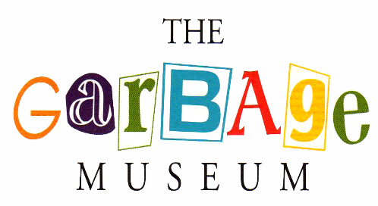
FREE /
This Photo by Unknown Author is licensed under CC BY-SA
½ PRICE
This Photo by Unknown Author is licensed under CC BY-NC
“DUMP DAY”
Don’t be a grouch – bring your trash to the dump and help keep our Town clean.
ALBURGH RESIDENTS ONLY

PROOF OF RESIDENCY REQUIRED
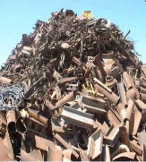
This Photo by Unknown Author is licensed under CC BY-ND
Residency Sticker as preferred proof

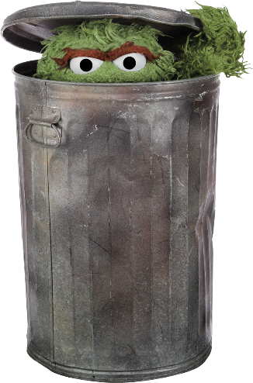
Residency stickers can be obtained at the Town Office.

HOUSEHOLD GARBAGE & METAL – FREE
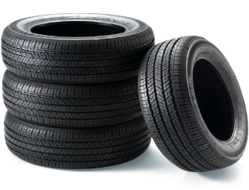
C&D, HOUSEHOLD REFUSE, & TIRES– ½ PRICE
This Photo by Unknown Author is licensed under CC BY-NC
SATURDAY, JULY 31st, 2021

