REQUEST FOR EARLY ABSENTEE VOTER BALLOT for (ONE YEAR ONLY)
(All voters including military and overseas voters must now submit a new request for absentee ballots each year.)
(SUBMIT DIRECTLY by fax, email or mail to the Town Clerk of the town in which you are on the voter checklist.)
FOR Civilian Voters Living in the U.S.:
Voter's Name: _____________________________________________________ (First, Middle, Last Name)
Check if last name is different than when you registered to vote--Former Name: __________________________
Voter's Current Mailing Address: _____________________________________________________________________

Voter's Town of Residence: __________________________________________________________________________

Telephone Number: ________________________Email Address: ____________________________________________
(Contact Only - NOT for Ballot Delivery)
I request early absentee voter ballot(s) for the election(s) checked below: (select Pres. Primary in Presidential Election years)
Annual Town Meeting All other local elections August Primary Election
Presidential Primary (1st Tuesday in March) YOU MUST SELECT PARTY: November General Election
Democratic Ballot Republican Ballot
Please deliver the ballot(s) as indicated below (check one):
Mail to voter at:
Street or PO Box Town/City State Zip Code
Deliver by two Justices of the Peace (This may only be selected if you are ill or physically disabled.)
Signature of Absentee Voter or Authorized Person Date
For Clerks Use Only: | Voted at town clerk's office  Ballot picked up at town clerk's office | Date Request Received: _______________________  Date Ballot Mailed: ________________________  Date Ballot Returned: _________________________
FOR Voters serving in the MILITARY (active U.S. or overseas) and OVERSEAS Voters:
Check one: Military (Active in U.S. or overseas) Overseas voter (not military)
Voter's Name:(First, Middle, Last Name) Voter's VT Town of Residence (before joining military or moving overseas): ___________________________
I request early absentee voter ballot(s) for the election(s) checked below:
Annual Town Meeting August Primary Election
Presidential Primary (1st Tuesday in March) YOU MUST SELECT PARTY: November General Election (select pres. Primary in Presidential Election years) Democratic Ballot Republican Ballot
Please deliver the ballot(s) and all election materials as indicated below (check one):
E-mail Address: (Blank ballot will be delivered by e-mail to the voter. All voted ballots must be mailed or sent by a delivery service to the town clerk.)
Fax to fax number: (You must provide country codes and all other codes or numbers necessary to fax successfully to the number provided from a VT telephone.)
Regular mail delivery to: (Print exactly as necessary to complete delivery to you.)
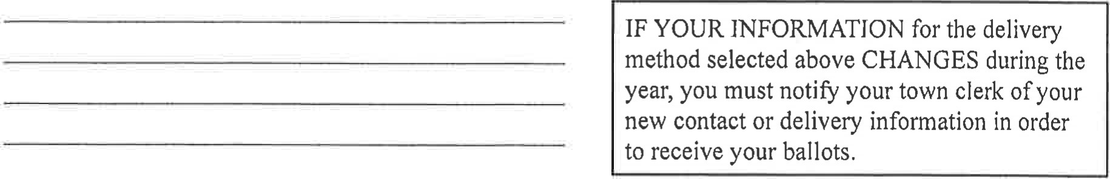
________________________________________ ___________________
Signature of Absentee Voter or Authorized Person Date

IF YOU ARE REQUESTING A BALLOT FOR SOMEONE OTHER THAN YOURSELF, you must complete the information below: (family member, health care provider, or person authorized by the absentee voter):
Name of Requestor: ________________________Signature: _______________________________ Date: _________
Organization Name (if applicable): ___________________________________________________________________
Address of Requestor: _____________________________________________________________________________
Relationship to Voter (check one): Family member Health care provider Person authorized by voter

